Nomvelo Zulu St10469528
Programming6212(POE Part 1)
Due Date : 04 September 2026

Section A

Race Day System-Entity Relationship Diagram

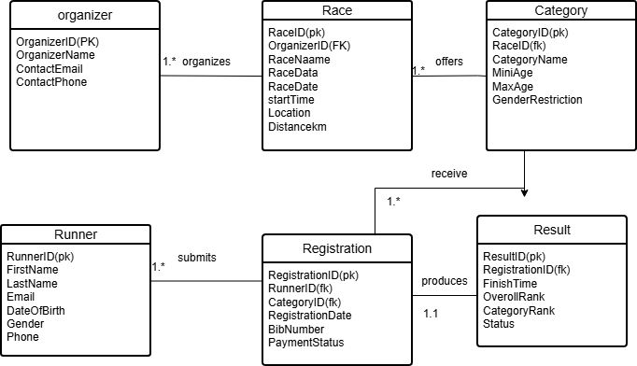

SECTION B

HTTP  Meth  od | Route | Description | Role Required | Request | Expected Response
Get | /api/races | Lists all races on the system. | None | None | 200 OK —  array of race  objects
Get | /api/races/{id} | Returns full details for one race. | None | None | 200 OK —  race object; 404 Not Found — race doesn't  exist
Post | /api/races | Creates a new race, linked to an organizer. | Admin | { raceName, raceDate, startTime, location, distanceKm, organizerId } | 201  Created — new race record; 400 Bad Request  —  invalid/mi ssing  fields
Put | /api/races/{id} | Updates an existing race's details. | Admin | { raceName, raceDate, startTime, location, distanceKm } | 200 OK —  updated race object; 404 Not  Found
Delet e | /api/races/{id} | Removes a race and its dependent  categories. | Admin | None | 204 No  Content; 404 Not  Found
Get | /api/races/{id}/categ ories | Lists the categories offered for a race (e.g. 5K,  10K). | None | None | 200 OK —  array of categories

Post | /api/races/{id}/categ ories | Adds a new category to a race. | Admin | { categoryNa me, minAge, maxAge, genderRestri ction } | 201  Created — new category record; 404 Not Found — race doesn't  exist
Post | /api/runners | Registers a new runner account. | None (public) | { firstName, lastName, email, dob, gender, phone } | 201  Created — new runner record; 409  Conflict — email already  registered
Get | /api/runners/{id} | Returns a runner's profile. | Runner (own) or Admin | None | 200 OK —  runner object; 403  Forbidden  ; 404 Not  Found
Post | /api/races/{id}/regist er | Registers a logged-in runner into a race category and issues a bib number. | Runner | { runnerId, categoryId } | 201  Created — registratio n record with bib number; 404 Not Found — race/categ ory doesn't exist; 409 Conflict — already  registered

Get | /api/runners/{id}/regi strations | Lists all race registrations for a runner. | Runner (own) or Admin | None | 200 OK —  array of registratio  ns
Delet e | /api/registrations/{id} | Cancels an existing registration.C ancels an existing  registration. | Runner (own) or Admin | None | 204 No  Content; 404 Not Found
Post | /api/registrations/{id}  /result  /api/races/{id}/result s | Records a runner's finish result for their registration. | Organizer/A dmin | { finishTime, overallRank, categoryRan k, status } | 201  Created — result record; 404 Not Found — registratio n doesn't exist; 409 Conflict — result already  submitted
Get | /api/races/{id}/result s | Returns the leaderboard/r esults for a race, sorted  by rank. | None | None | 200 OK —  array of result objects

SECTION C
Create Database RaceDayDB; use RaceDayDB;

Create table Organizer(
OrganizerID int identity(1,1) primary key, OrganizerName VARCHAR(150) NOT NULL, ContactEmail VARCHAR(90) NOT NULL, ContactPhone VARCHAR(10) NOT NULL
);

Create table Race(
RaceID int identity(1,1) primary key, OrganizerID int,
RaceName VARCHAR(100) NOT NULL,

RaceDate DATE NOT NULL, StartTime TIME NOT NULL,
Location VARCHAR(250) NOT NULL, DistanceKm DECIMAL(5,2) NOT NULL,
FOREIGN KEY (OrganizerID) REFERENCES Organizer(OrganizerID)
);

Create table Category(
CategoryID int identity(1,1) primary key, RaceID int,
CategoryName VARCHAR(100) NOT NULL, MinAge INT NOT NULL,
MaxAge INT NOT NULL,
GenderRestriction VARCHAR(20) NOT NULL, FOREIGN KEY(RaceID) REFERENCES Race(RaceID)
);

Create table Runner(
RunnerID int identity(1,1) primary key, FirstName VARCHAR(70) NOT NULL, LastName VARCHAR(70) NOT NULL, Email VARCHAR(90) UNIQUE NOT NULL,
DateOfBirth DATE NOT NULL, Gender VARCHAR(20) NOT NULL, Phone VARCHAR(10) NOT NULL
);

Create table Registration(
RegistrationID int identity(1,1) primary key, RunnerID int,
CategoryID int,
RegistrationDate DATE NOT NULL, BibNumber VARCHAR(10) NOT NULL,
PaymentStatus VARCHAR(20) NOT NULL CHECK (PaymentStatus IN ('Paid', 'Pending', 'Refunded')),
FOREIGN KEY(RunnerID) REFERENCES Runner(RunnerID), FOREIGN KEY(CategoryID) REFERENCES Category(CategoryID)
);

Create table Result(
ResultID int identity(1,1) primary key, RegistrationID int UNIQUE, FinishTime VARCHAR(10), OverallRank INT,
CategoryRank INT,
Status VARCHAR(20) NOT NULL,
FOREIGN KEY(RegistrationID) REFERENCES Registration(RegistrationID)
);

-- POPULATE TABLES

-- Organizer

INSERT INTO Organizer (OrganizerName, ContactEmail, ContactPhone) VALUES ('Cape Town Athletics Club', 'info@ctac.co.za', '0211234567'),
('Johannesburg Runners Assoc', 'contact@jra.co.za', '0117654321'), ('Durban Coastal Runners', 'hello@dcr.co.za', '0319988776');

-- Race
INSERT INTO Race (OrganizerID, RaceName, RaceDate, StartTime, Location, DistanceKm) VALUES
(1, 'Cape Town Peace Run', '2026-10-10', '06:00:00', 'Green Point, Cape Town', 10.00),
(1, 'Table Mountain Trail Run', '2026-11-15', '05:30:00', 'Table Mountain, Cape Town', 21.10),
(2, 'Joburg City Marathon', '2026-09-20', '06:00:00', 'Sandton, Johannesburg', 42.20),
(3, 'Durban Beachfront Fun Run', '2026-10-05', '07:00:00', 'North Beach, Durban', 5.00);

-- Category
INSERT INTO Category (RaceID, CategoryName, MinAge, MaxAge, GenderRestriction) VALUES
(1, 'Open 10km', 18, 65, 'Mixed'),
(1, 'Junior 10km', 12, 17, 'Mixed'),
(2, 'Half Marathon Open', 18, 60, 'Mixed'),
(3, 'Full Marathon Open', 18, 60, 'Mixed'),
(3, 'Full Marathon Veteran', 45, 70, 'Mixed'),
(4, 'Fun Run Open', 10, 70, 'Mixed');

-- Runner
INSERT INTO Runner (FirstName, LastName, Email, DateOfBirth, Gender, Phone) VALUES ('Thabo', 'Mokoena', 'thabo.mokoena@email.com', '1995-03-14', 'Male', '0821234567'),

('Sarah', 'Naidoo', 'sarah.naidoo@email.com', '1998-07-22', 'Female', '0839876543'),
('Johan', 'van der Merwe', 'johan.vdm@email.com', '1988-11-02', 'Male', '0824567890'), ('Lerato', 'Dlamini', 'lerato.dlamini@email.com', '2001-05-19', 'Female', '0837654321'),
('Michael', 'Botha', 'michael.botha@email.com', '1975-01-30', 'Male', '0825551234'),
('Nomvula', 'Khumalo', 'nomvula.khumalo@email.com', '1993-09-08', 'Female', '0836667788');

-- Registration
INSERT INTO Registration (RunnerID, CategoryID, RegistrationDate, BibNumber,
PaymentStatus) VALUES
(1, 1, '2026-09-01', '1001', 'Paid'),
(2, 1, '2026-09-02', '1002', 'Paid'),
(3, 3, '2026-08-20', '2001', 'Paid'),
(4, 4, '2026-08-25', '3001', 'Pending'),
(5, 5, '2026-08-26', '3002', 'Paid'),
(6, 6, '2026-09-03', '4001', 'Refunded');

-- Result
INSERT INTO Result (RegistrationID, FinishTime, OverallRank, CategoryRank, Status) VALUES
(1, '00:45:12', 3, 1, 'Finished'),
(2, '00:48:30', 7, 2, 'Finished'),
(3, '01:35:47', 1, 1, 'Finished'),
(4, '04:15:22', 15, 5, 'Finished'),
(5, '04:02:10', 10, 1, 'Finished'), (6, NULL, NULL, NULL, 'DNS');

REFERENCES
Elmasri, R., & Navathe, S. B. (2016). Fundamentals of database systems (7th ed.). Pearson.
Microsoft. (2024). Transact-SQL reference (Database Engine). Microsoft Learn. https://learn.microsoft.com/en-us/sql/t-sql/language-reference
Coronel, C., & Morris, S. (2019). Database systems: Design, implementation, and management (13th ed.). Cengage Learning.
W3Schools. (n.d.). SQL tutorial. https://www.w3schools.com/sql/
Date, C. J. (2004). An introduction to database systems (8th ed.). Addison-Wesley.
Microsoft. (2024). CREATE TABLE (Transact-SQL). Microsoft Learn. https://learn.microsoft.com/en-us/sql/t-sql/statements/create-table-transact-sql
Chen, P. P. (1976). The entity-relationship model—Toward a unified view of data. ACM Transactions on Database Systems, 1(1), 9–36. https://doi.org/10.1145/320434.320440
Connolly, T., & Begg, C. (2015). Database systems: A practical approach to design, implementation, and management (6th ed.). Pearson.

Part 2

VS Code
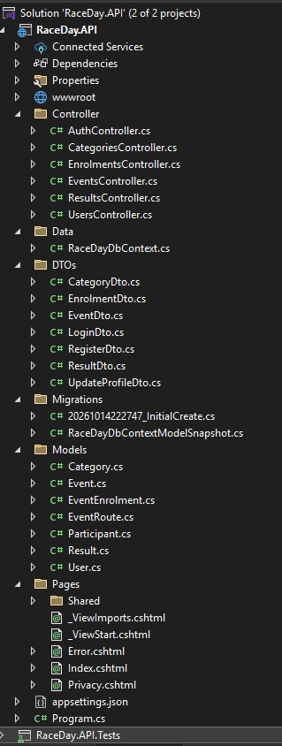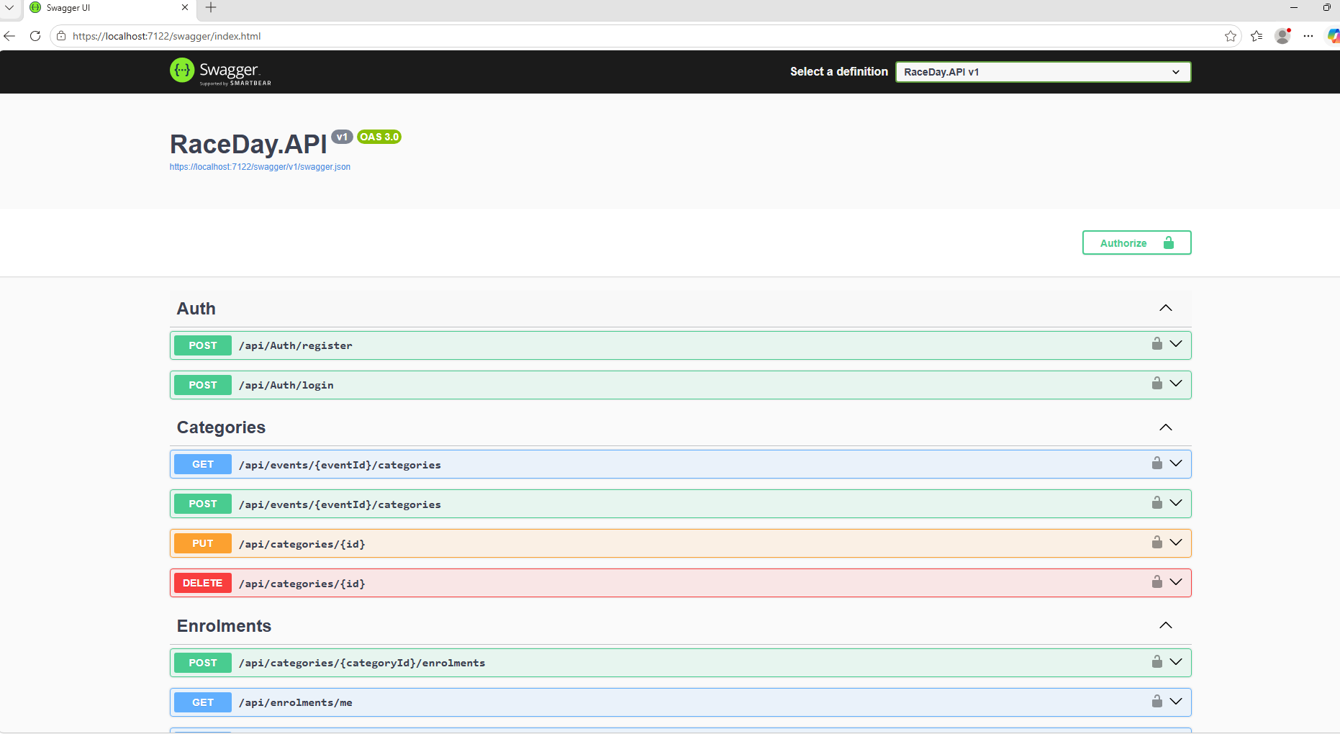
https://localhost:7122/swagger/index.html

Tests
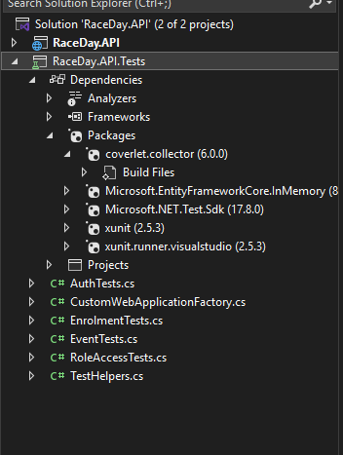
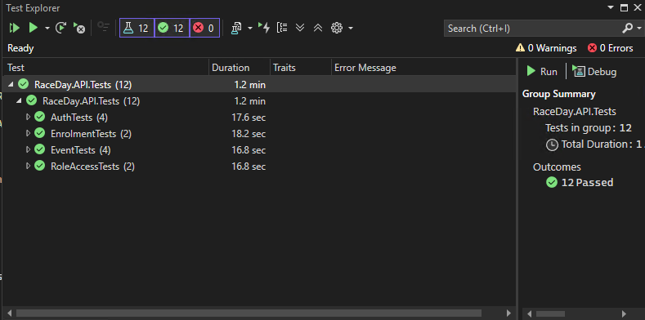

Git Hub

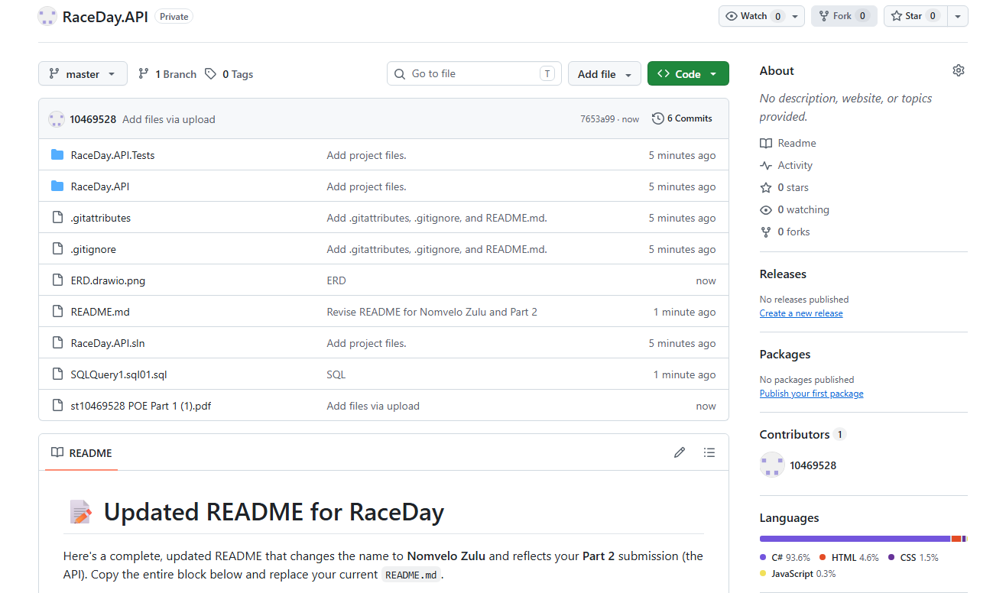
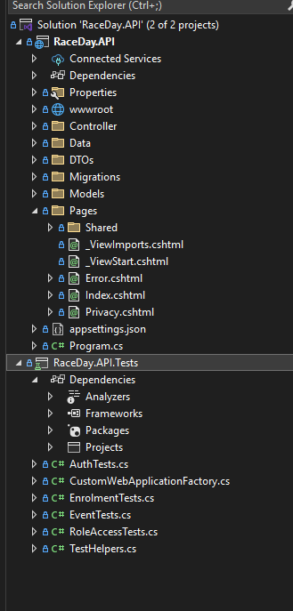

YouTube link

